CSI Update of the Energy Revolution 2015: Snapshot of Markets and Technologies

Introduction
Since the spring of 2013 CSI has conducted informal surveys of energy markets and technologies. Nearly two years ago, it was evident that a revolution in energy technology and cost reductions in those technologies was taking place. The revolution has continued as the global market for solar and wind technology has surged. As coal-fired and nuclear power struggle economically, the emerging paradigm evolving to its seemingly inevitable end is an electric grid dominated by building efficiency (moving towards net zero energy buildings and communities) and solar and wind technology. Coupled with the growing efficiency/renewables market is an equally strong investment and R&D interest in storage technology. Out of this is emerging yet another development - an electric grid/transportation nexus. It is apparent that the electric/hybrid vehicle market will play an increasing role in the integration of variable renewable technology (solar and wind) into the grid.

The commercialized technologies among these continue to display inherent advantages over base-load coal-fired and nuclear plants and central station natural gas-fired plants. And commercialization of other sustainable technologies mentioned herein will no doubt exhibit similar attributes.

- Continued cost reductions
- Ease and pace of deployment
- Minimal financial risk (no cost overruns during construction)
- Calculable construction and operating costs
- Few impacts on water quality and availability
- Modular design (able to be sized properly for any operational context)
- Minimal impacts on public health
- Grid resiliency attributes
- Minimal climate impacts
- Able to be mass-produced

Another distinct advantage of renewable, storage, building efficiency, fuel cell and wave technologies often overlooked is that they, unlike new nuclear or coal-based power plant designs, can be thoroughly tested over a number of unit generations until they are ready for commercialization. On the other hand, no utility company or its stockholders will support billions in investment over a decade or more of a full-scale power plant or unit to properly commercialize so-called Generation IV nuclear or coal gasification or supercritical designs. These designs exist on paper only. If they are deployed, construction begins as an experiment (hence the inevitable cost overruns) with massive public R&D and financial support behind them. The battery of public largesse includes loan guarantees, construction work in progress, and federal and state tax credits. Only after all or a substantial portion of the construction risk is shifted to the public (in other words, only after significant construction subsidies are in place) will the private sector consider financial support for such projects.

This year we add fuel cells to the list. Similar to the other sustainable technologies mentioned in this paper, a global fuel cell market is emerging.

Globally, the renewables market remains healthy, with solar PV and wind deployment leading the way. In early 2015, Bloomberg Energy Finance reported that global investment in renewables increased in 2014 for the first time since 2011, reaching $310 billion. Bloomberg and other analysts did not expect this given low oil prices, which appear not to have had much, if any, impact on renewables investment.

The surge in investment was led by solar PV, which increased 25% year-to-year to $149.6 billion. The rise in wind investment was mainly from offshore deployment, “achieving an all-time high of $99.5 billion” (increasing by 11%). Rooftop solar assumed second place, expanding “34 percent to $73.5 billion.”

China, at $89.5 billion in investment, led the way, representing 32% of the increase. The US enjoyed $40.8 billion in renewables investment.

US non-hydro renewables account for about 6% of all US electric generation; adding hydro the sum reaches about 13%. In November of 2014, US wind and solar capacity additions made up 70% of new generation. Nine of 11 months renewables were on top of capacity addition stats. During 2014, renewables comprised over 47% of new generation – “wind accounted for 23.11%, followed by solar (20.16%), biomass (2.58%), hydropower (1.29%) and geothermal (0.29%).” Natural gas dominated the balance of power plant additions.

In terms of job creation/loss, renewables beat conventional power plants from 2011 through June 2014. The fossil fuel power sector lost over 1,700 (mainly coal) and the nuclear power plant sector 4,800. These were due to power plant closures. Wind and solar jobs increased 16% and 201% respectively.
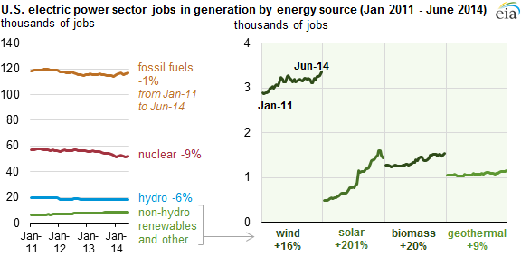
Source: Bureau of Labor Statistics
Quarterly Census of Employment and Wages (Note: 2014 data are preliminary)

The Solar Market and Technologies
Solar Market
The market in the US is shifting from commercial and utility solar installations to home installations. In the first quarter of 2014, solar represented 74% of new renewable and natural gas capacity additions, and rooftop solar overtook commercial scale installations. Moreover, the solar capacity additions in that quarter were 79% higher than the first quarter of 2013, amounting to an installation in the US every 3 minutes and “signaling towards a more reliable growth market for investors.” In addition to developing into a resilient market, solar costs are beginning to rival those of natural gas plants. According to a recent study, distributed energy resources in general are poised to “cost utilities up to $48 billion annually by 2025.”

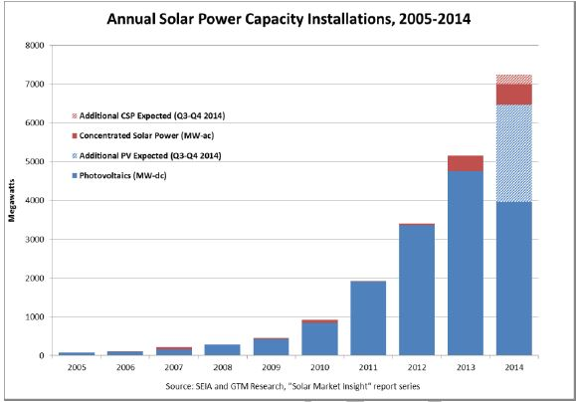
Source: Solar Foundation

The trend in 2013 accelerated in 2014. 2014 saw a solar systems being installed every 2.5 minutes, with the residential sector leading the way, on $15 billion of investment. The number of installations reached 200,000 homes accumulatively and is expected to climb to 900,000 this year and be over one million in 2016. The remarkable pace of the solar PV build-out is punctuated by comparing the rate of installations ten years ago. At that time, one installation occurred every 2 hours.

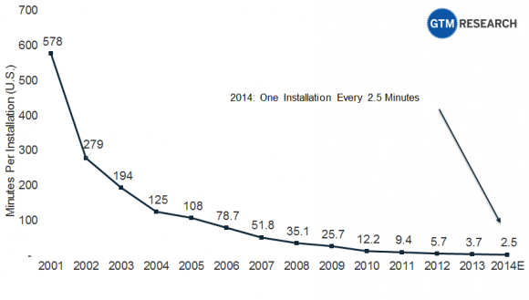
Source: GTM Research

The US is now home to more than 16 gigawatts (16,000 megawatts) of solar PV, up from 1.2 gigawatts 5 years ago. 2014 was also the biggest year for concentrating solar facilities, which experienced additions of 767 megawatts. While the residential market continues to gain momentum, the commercial solar PV market has remained and is expected to remain flat. Estimates are that the US will enjoy 8,000 megawatts of installations in 2015 and 12,000 in 2016. Another interesting development is that third-party owned installations represent 67% to 92% of the market in New York and New Jersey respectively but less so in California and Nevada. In these states, companies are beginning to give out loans and customers are beginning to pay cash due to the price reductions solar PV has experienced over the last 4 to 5 years.

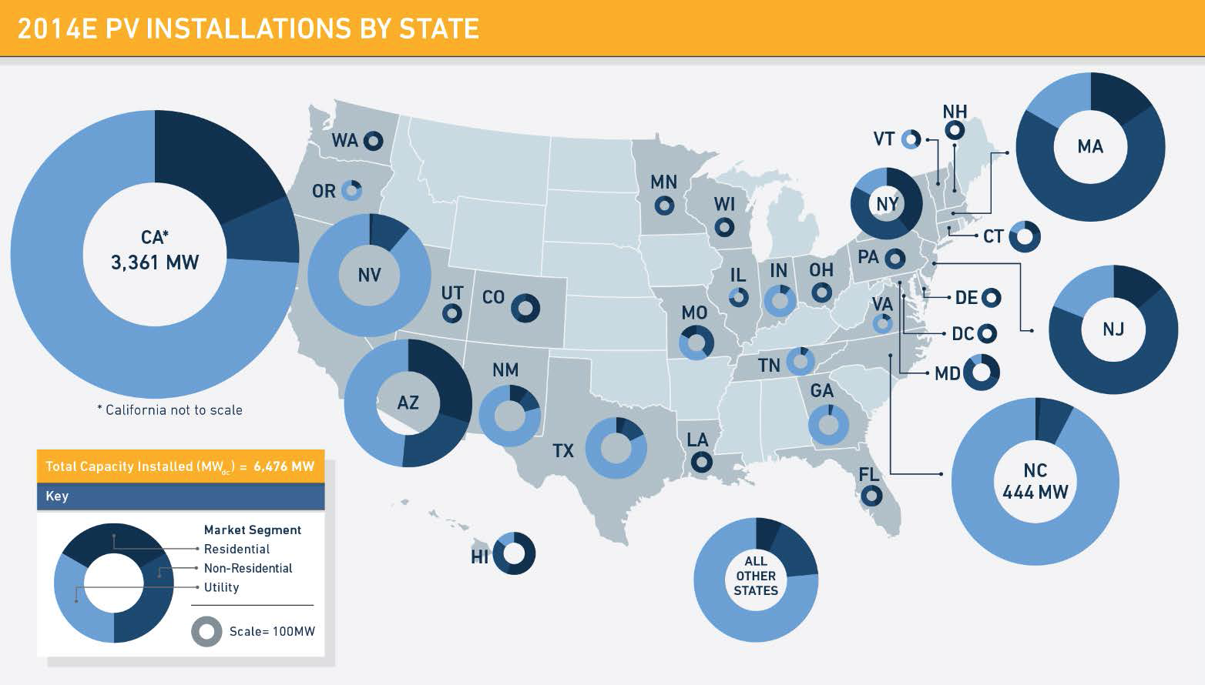
Source: SEIA & GTM Research

In terms of solar jobs, this graph speaks for itself:

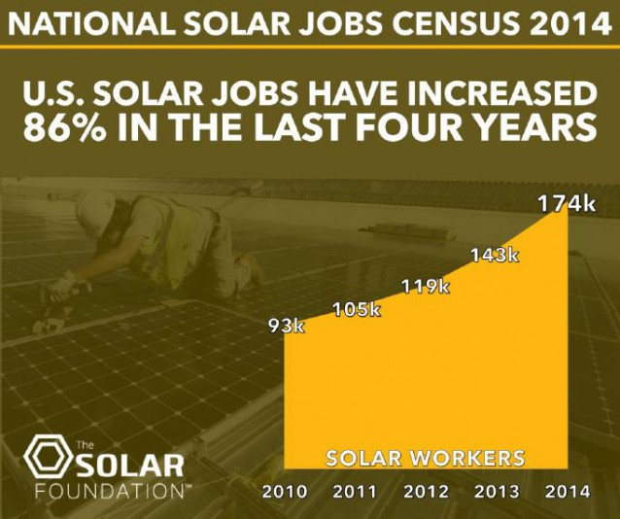
Source: Solar Foundation

The global market is also expected to remain healthy and grow. UBS (a financial services firm) estimates that “[a]s a result of rapid growth, we expect the solar industry (modules and installations) to surpass the $100 billion threshold in 2016 already.” Morgan Stanley predicts 47 gigawatts (47,000 megawatts) of global solar installations per year through 2020, with the US carving out 8 gigawatts, China 13 gigawatts and Europe 10 gigawatts per year. Deutsche Bank predicts 54 gigawatts of solar PV capacity additions in 2015. Citigroup predicts a robust global solar market, “dismissing the International Energy’s Agency estimate of $1.3 trillion investment by 2030 as highly conservative.” (As a comparison, it takes nearly decade to build 1 or 2 thousand megawatts of nuclear power in the US at excessive
cost, and solar is not plagued by cost overruns or construction delays that plague the nuclear industry.

Improving Solar Cell Efficiency
Major breakthroughs in solar research have the potential of greatly enhancing the efficiency of solar cells.

By splitting sunlight into 4 different cells, instead of just using one as is currently the case, researchers at the University of South New Wales (Australia) have reached cell efficiencies of 40% in outdoor tests in Sydney and the US. They hope to achieve 45% efficiency in the next few years. The researchers assert that since they are using commercial cells “in a new way,” the industry will be able to readily adopt the technology once it has been piloted.

Soitec and CEA-Leti in France, with support of Fraunhofer Institute for Solar Energy Systems in Germany have developed a new multi-junction solar cell, reaching efficiencies of 46%. Multi-junction cells use different materials to convert a broader spectrum of light into electricity. Researchers believe that efficiencies of as high as 50% can be achieved. Soitec and CEA-Leti have built a manufacturing line in France to produce the new cells.

Still at the laboratory stage, researchers at Cambridge, in an experiment, combined silicon (the basis of solar cells) and organic matter found in leaves (Pentacene) that can transfer photons to silicon to produce electricity. Researchers said the hybrid solar cell was 95% efficient. The team of researchers is currently working on a “low-cost organic coating” in preparation for pilots and demonstrations.
North Carolina State University and Hong Kong University of Science and Technology are working with new polymers in polymer solar cells that achieved a record 11% efficiency for polymer solar cells in laboratory tests. They believe that these can eventually be mass-produced cheaply.
Researchers at Toronto University’s Applied Science and Engineering department have developed a new way to apply tiny solar cells to any surface. They could be applied to cars, airplane wings, patio furniture, just about anything. Covering the roof of a car could power 3 100-watt light bulbs. Instead of cumbersome batch processing, the researchers developed a way to spray the solar cells with readily available equipment. The hope is to work towards inexpensive mass-production.

Solar Roads
In November of 2014, the Dutch Organization for Scientific Research installed a 230-foot length of solar road on a bike trail in the province of North Holland as a demonstration project. It is protected by two layers of safety glass and will power three average Dutch homes.

Solar Roads is a US firm that has developed a solar road paving system. Panels can be installed on any surface like parking lots, roads, bike paths, playgrounds, driveways. The panels are designed to carry the heaviest loads (e.g. from semis). The firm has developed the system and is wrapping up a parking lot demonstration project. It now is working to attract financing for production of the panels. The panels contain heating elements to melt snow and ice and LEDs to illuminate lanes and can accommodate data cables.

Solar Windows
Over the last few years, New Energy Technologies has further developed its solar window. The company has developed a system to spray on solar cells to windows that remain transparent. The problem in the past was the size of the window. Recently, the company was able to produce a much larger version – over 2 square feet. Since the cells can convert electricity from diffuse light, the windows can to mounted to any side of a building. Researchers at the company also note that their spray-on method lends itself to mass-production, which would hold costs down.

Wind Power Market and Technologies
Market
Wind energy has grown 24 times since 2001. Iowa receives 27% of its power from wind turbines. Nine states receive at least 12% of their power from wind turbines (Colorado, North Dakota, South Dakota, Iowa, Minnesota, Oklahoma, Kansas, Idaho, and Oregon).

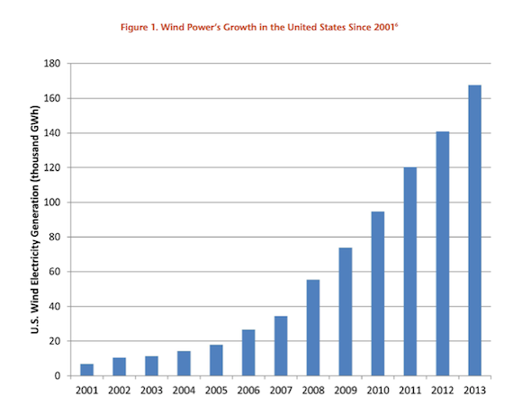
Source: Published in Truthdig

The US has over 62,000 megawatts of wind turbines installed and operating. Due to the late extension of the production tax credit in 2013, only somewhat over 1,200 megawatts came on line in the first 3 quarters of 2014. However, 13,600 megawatts are currently under construction. It is unclear how construction will unfold past 2015.

AWEA reports that 14 offshore projects are in advanced stages of development. However, no offshore wind turbines have been installed off US shores. (Recently, Cape Wind lost its power contracts.)

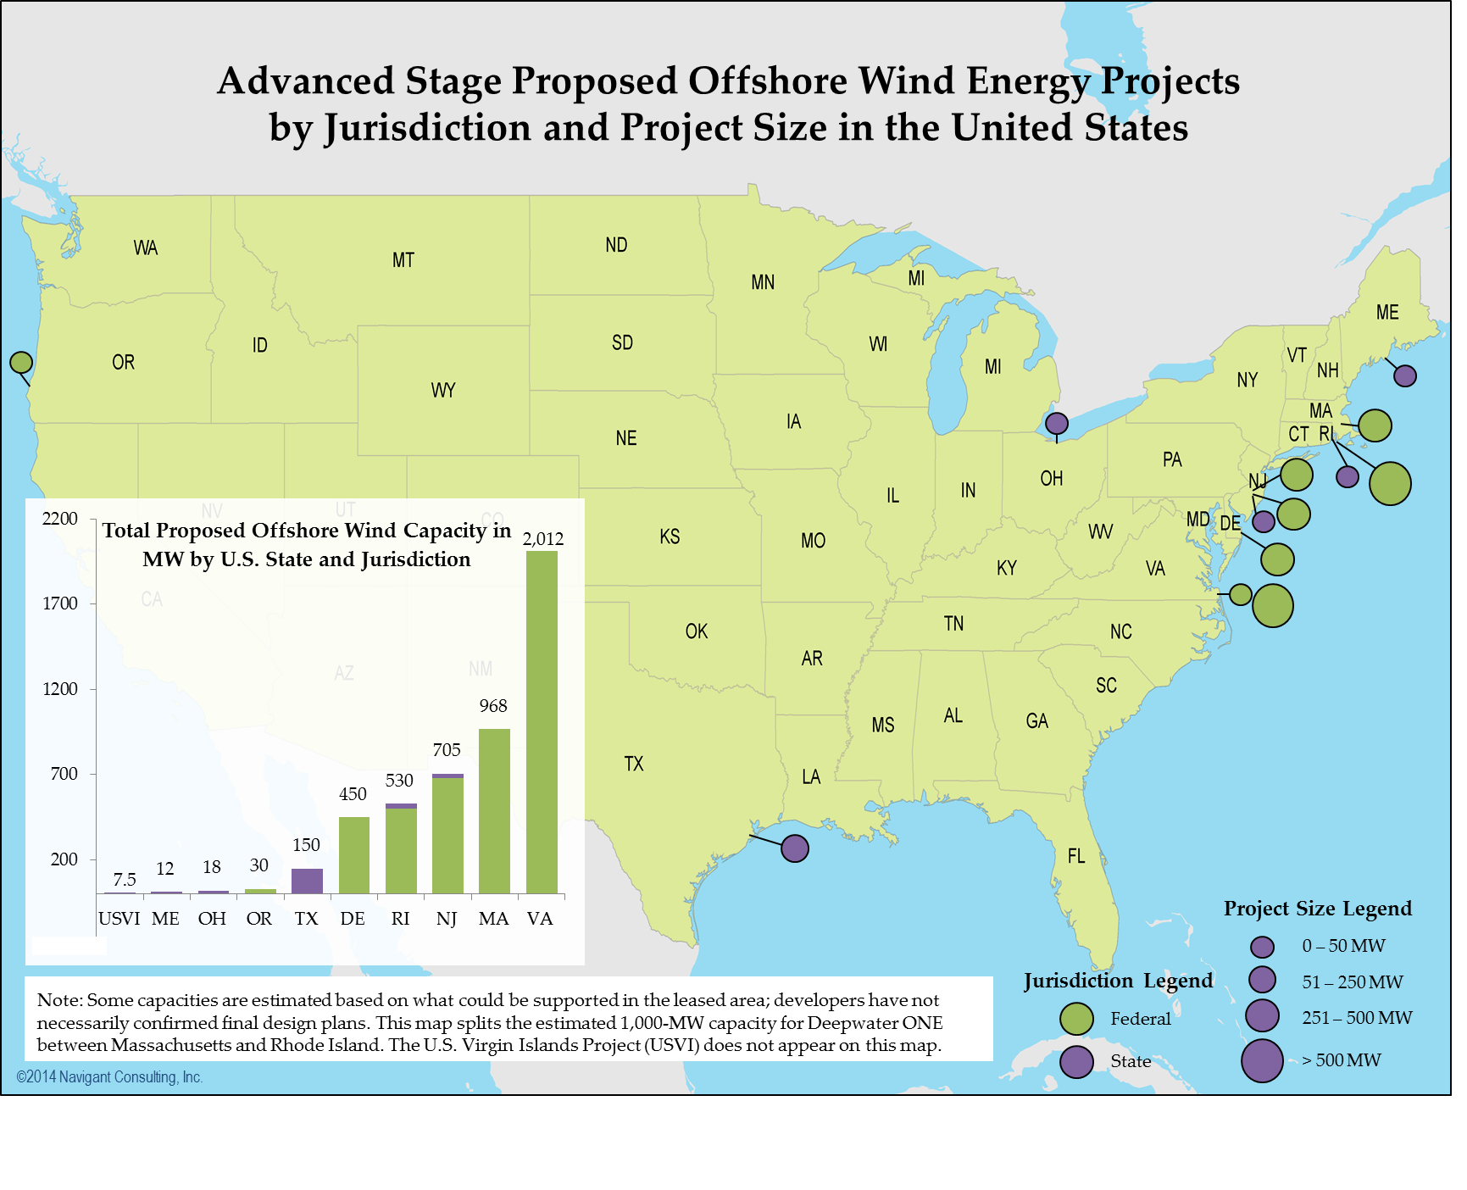
Source: AWEA

Prior to Cape Wind contract cancellations, AWEA predicted 3,700 megawatts of installed offshore wind turbines by 2021.

Currently, there are 7 gigawatts of global installed offshore wind. The typical size of a turbine is 4 megawatts, but estimates are that turbine size will reach 5 and larger by 2018. Most of the construction is in Northwestern Europe and China. But the United Kingdom installed over 800 megawatts in 2013. 29 projects amounting to 6,600 megawatts are under construction globally now, with China constructing 1,000 megawatts.

US offshore wind potential is substantial. Potentially two to four times the amount of all installed US power plant capacity.

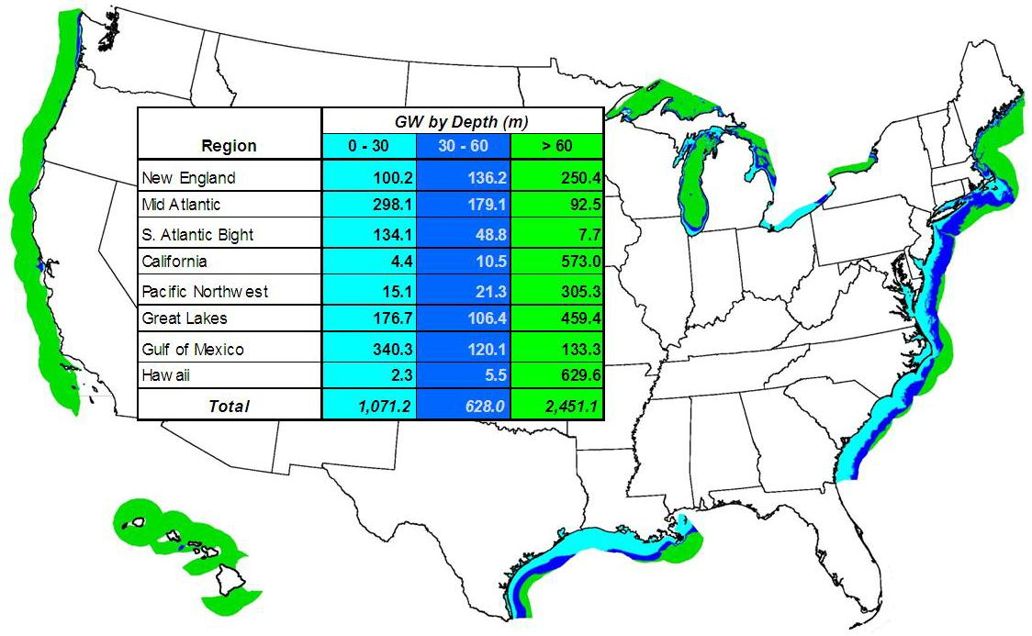
United States offshore wind resource by region and depth (Credit: NREL)

The EU accounts for 111 gigawatts of onshore installed wind capacity, providing 8% of all of the EU’s power by the end of 2013. Analysts predict global wind turbine capacity to reach 600 gigawatts by the end of 2018, double what it was in mid-2014.

In terms of market segments, the scale of investment is quite large. As an example, MarketandMarket estimates the wind turbine rotor blade market to be worth nearly $17 billion by 2019.

Advances in Technology
Over the last 10 years, wind turbine capacity factors have increased from an average of 25% to over 50%. Blades extended further (with the rotor assembly now over 100 meters (over 300 feet) in diameter for new models), hub heights increased, improvements were made with electronics and controls (to handle wind gusts), and wind forecasts honed. GE has increased the availability of its wind turbines from 80 to 85% ten years ago to 98% now.

With older wind turbines, upgrades are needed. GE recently discussed its “blade extension” technique at a wind conference in Las Vegas. Its 1.5 megawatt turbines had a rotor diameter of 77 meters. GE cuts the blades in half and inserts an extension making the diameter 91 meters thereby increasing its annual output, the company claims, by 20%. GE also is testing a new model with a hub height of 139 meters. The company says that the hub height is not limited to 140 meters (nearly 460 feet).

Vestas is testing its new 8-megawatt offshore wind turbine. In a 24-hour period it set a record for turbine output, enough to power over 13,000 homes.

GE is commissioning its Boco Rock wind farm in Australia, which features its Brilliant Wind Turbine (the turbines communicate with one another to maximize output and are tied to batteries to flatten output during startups and stops). The wind farm should be fully operational in January of 2015.

The Torque Wind Turbine is a recent innovation in small wind turbines. It will operate at 10 to 40 meters (up to 130 feet) and is designed to generate maximum output (anywhere from 3 to 100 kilowatts of power) in low wind speeds. In terms of maintenance, there is no gearbox and no lubrication needs on the unit.

Torque Wind Turbine

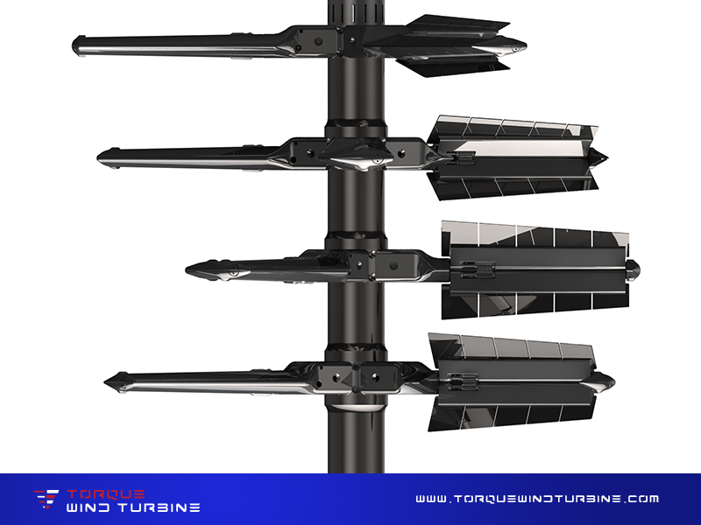

Storage Market and Technologies
Types of Storage Technology and Their Roles on the Grid
The focus of this paper is two types of storage technology that are being deployed, near/at commercialization or in pilot/demonstration stages:

Mechanical: compressed air storage, flywheel storage
Electro-Chemical: rechargeable battery, flow battery, Ultra-capacitors

Ultimately, these technologies (along with demand response options) will replace natural gas-fired power plants that provide peak power and smooth variable generation in solar PV and wind farm output. These technologies are designed to correct fluctuations in the grid for periods of seconds, minutes, or hours. They will ultimately cover any contingency grid operation requires. Their capabilities are superior to those of natural gas-fired power plants in terms of response time and spectrum of output – anywhere from zero to maximum within fractions of a second. They will also play a pivotal role in micro-grid development.

A question that comes to mind is what sources of power will be used to support these technologies. As it happens, as the percentage of generation from solar PV and wind turbines grows, the more excess power will be generated – either during the day when solar and/or wind output is particularly high or at nighttime when low demand creates excess power from wind turbines. Ultimately, energy to storage technologies will be powered/charged solely by renewables.

What storage technologies do is make variable solar PV and wind dispatchable. Stored solar and wind energy can be provided when needed.

Having said this, however, storage is not required for substantial penetration of wind and solar PV to occur. This is a fallacy engendered by those who want to slow solar and wind development. PJM (the eastern US regional transmission organization) recently published a study stating that variable renewable penetration could be has high as 30% before substantial changes to the grid were needed.

General Market
The literature seems to be focused mainly on the battery storage market.

According to the DOE energy storage database, there are currently 863 global storage projects either operational, under construction, or decommissioned amounting to over 145 gigawatts. There are over 3.5 gigawatts operational, 571 projects. In terms of gigawatts, pumped storage leads followed by electro-mechanical and then electro-chemical projects. In terms of projects, there are far more electro-chemical projects than any other currently operating. The top countries in most categories are Japan, China, and the US - although Germany, Spain, the UK, and Italy are strong participants in certain categories as well. There has been a noticeable uptick in projects since 2007. Navigant reports that almost 400 megawatts of energy storage projects were announced globally in 2014 (equally divided between North America, the Asia-Pacific, and Europe) and IHS predicts global storage capacity to rise “6 gigawatts per year by 2017, reaching 40 gigawatts by the end of 2022.

Battery Market and Technologies
Market
Navigant, an energy market research firm, expects global battery storage capacity to reach 20.8 gigawatts by 2024, from just under 600 megawatts today. These technologies will provide “electric supply reserve capacity (currently fulfilled by overbuilt fossil and nuclear power plants), grid frequency regulation (over seconds to minutes), load following (tracking the increase and decrease of demand during the day over hours), transmission and distribution upgrade deferral, voltage support (over seconds to minutes)” …. and utility-scale solar and wind integration. Monetarily, the utility-scale battery market in the US will climb from $164 million in 2014 to $2.5 billion to 2023. Navigant expects the distributed battery storage market to increase from $452 million annually in 2014 to $16.5 billion annually by 2024.

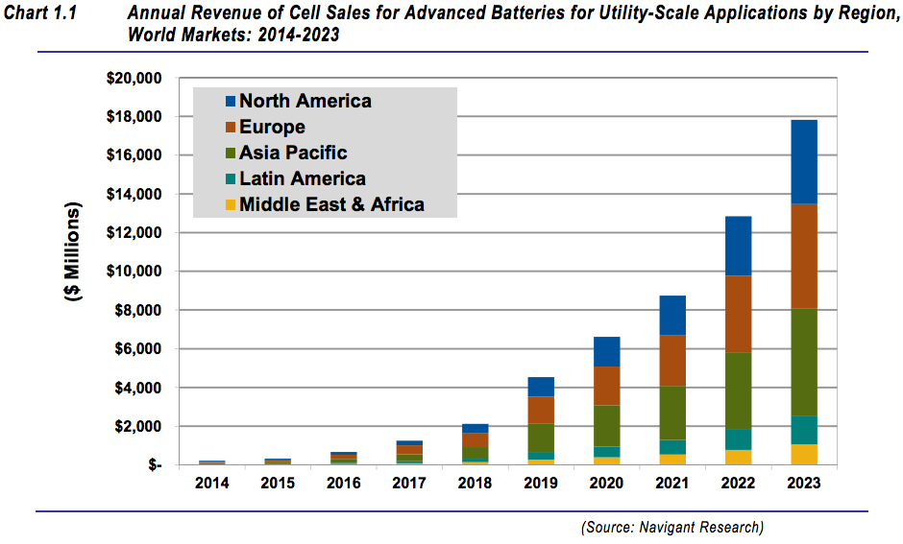

Near-term prospects for battery storage appear positive. One industry representative says utility scale storage is already competitive with natural gas. Others predict that battery storage will be competitive with natural gas globally (including the US) within 18 months. Lithium-ion batteries declined in price over the last 4 years by 40% and are expected to fall another 40% in 3 to 5 years. The target price for battery storage on the wholesale market is under $500/kilowatt hour at which point, analysts believe, the market will take off. Some manufacturers are reaching that mark now or soon will.

The “solar-plus-storage” market is set to expand significantly by 2018. Analysts believe that this will happen first in the commercial sector where high demand charges can be offset by storage technology and returns are high – 16 to 23% in 2014 and 15 to 50% percent with high demand charges. (For the residential market it’s currently 6 to 14%.) This market is estimated at $6 billion. These facilities can also provide services to the grid. As depicted here:

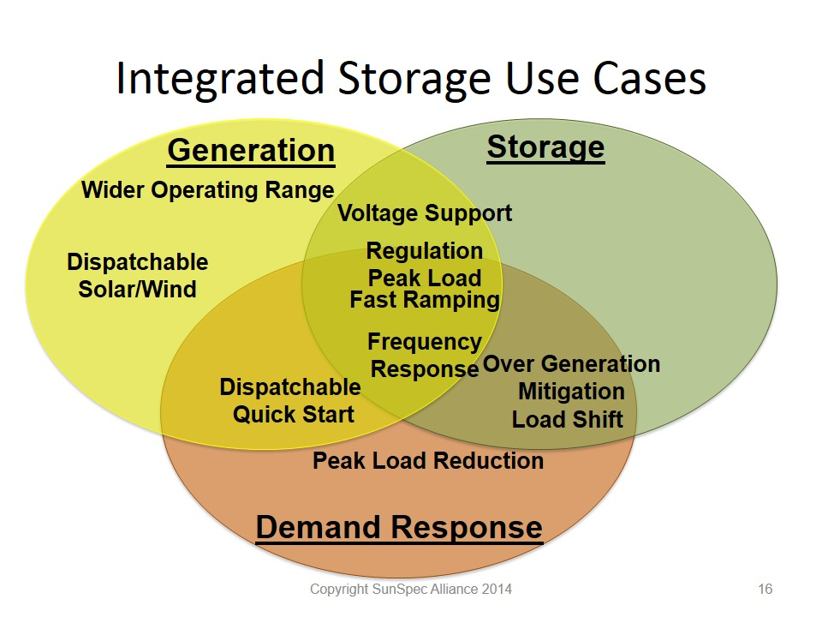
Source: SunSpec Alliance 2014

GTM Research estimates that the US will see 318 megawatts of “behind-the-meter” (customer) solar and storage from now through 2018. The major US markets are developing in California the Northeast, and Hawaii. The State of California has mandated 1.3 gigawatts by 2020. In the wake of hurricane Sandy (and increased for electric grid resiliency), New York, Connecticut, New Jersey and Massachusetts has launched state initiates, which could be valued at hundreds of millions of dollars of storage investment.

Tesla Motors gigawatt (net zero energy) battery factory in Reno will double current global lithium-ion battery production. Tesla intends to manufacture 500,000 cars per year by 2020.

Source: Tesla Motors
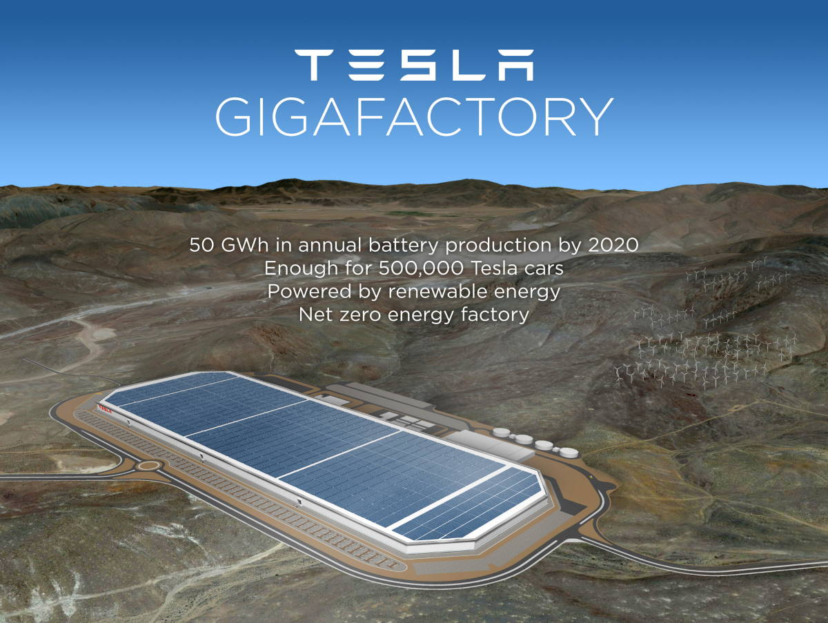

Battery Technologies
Researchers at Oakridge Lab demonstrated in 2013 a new lithium-ion battery using nano-technology to create a solid electrolyte that is much lighter and safer and will be able to store 5 to 10 times more energy.

Flow batteries are entering the market. Flow batteries are like a combined fuel cell and battery. One such technology is “Nanoflow Technology” incorporated by the small, German automaker Quant into an electric car. Now ready to be driven on EU roads (it passed safety inspections) but quite expensive, the battery stores energy essentially in salt water. The car, the company says, can travel 373 miles prior to replacing/recharging the electrolyte, accelerate from 0 to 60 in 2.8 seconds, and reach speeds of over 200 miles per hour. The battery has stationary applications as well.

Here’s a description of the technology:
“The system works in a similar way to a hydrogen fuel cell, except for the fact that salt water is used for storing power. In particular, two liquids with metallic salts, which act as the electrolyte, are combined in such a way that the electrochemical reaction takes place. After that, electric motors use this reaction to generate electricity, which is then stored and distributed by super capacitors. The efficiency of this system reaches 80%, since the car has almost no moving parts in it, and the produced waste heat is insignificant in comparison with cars powered by lithium-ion batteries.”

Other technologies being developed or entering the market are sodium-ion batteries and liquid metal batteries. Sodium-ion batteries are based on sodium salts are much more readily available than lithium salts. The idea is that they could be ultimately cheaper to manufacture. In 2014, Aquion (a battery company) brought to the market a sodium-ion based battery at a cost comparable to a lead acid battery to be used as backup power in microgrid designs. Liquid metal batteries use liquid positive and negative electrodes. Their strength is that they are considered very durable and can hold 85% of their charge after a decade of cycling on the grid in backing up variable wind and solar PV. However, others believe lithium-ion batteries will continue to dominate.

EOS, another battery company, has developed a zinc hybrid cathode battery over the last decade. It plans to offer them on the market for $200/kWh to $250/kWh. They could be used to replace natural-gas fired plants on the grid, to smooth variable generation, or in electric cars.
Compressed Air Storage Market and Technology
The compressed air storage market is about to expand. No megawatt-scale compressed air storage facility has been built since 1991. Traditionally, air was compressed underground and then released and mixed with natural gas, which greatly reduced the amount of natural gas required to run a turbine. Now SustainX, a company that has been developing a new technology, is testing a 1.5 megawatt unit and considers it ready for commercialization. Testing was to be completed by the end of 2014. The DOE helped to fund this demonstration and testing.

SustainX Isothermal Compressed Air Storage Unit
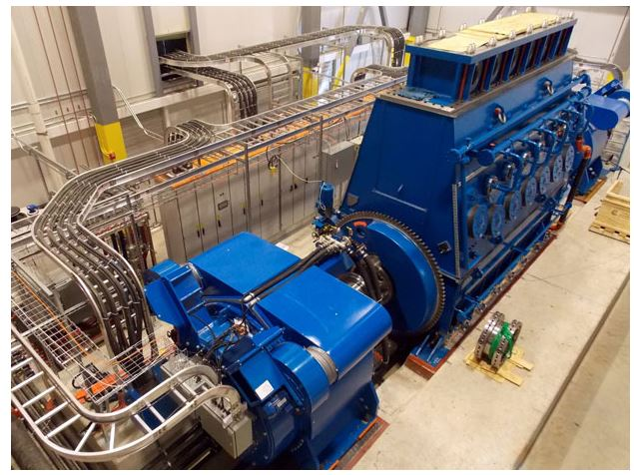
Source: SustainX

The technology uses no fuel. The company developed a trade secret foam that stores and exchanges heat and runs an engine. The heat is stored in tanks that can be sized as appropriate (modular) for a few to many hours of operation.
Navigant believes that the technology will ramp up globally to about 2,700 megawatts per year by 2023 and can serve multiple purposes on the grid.

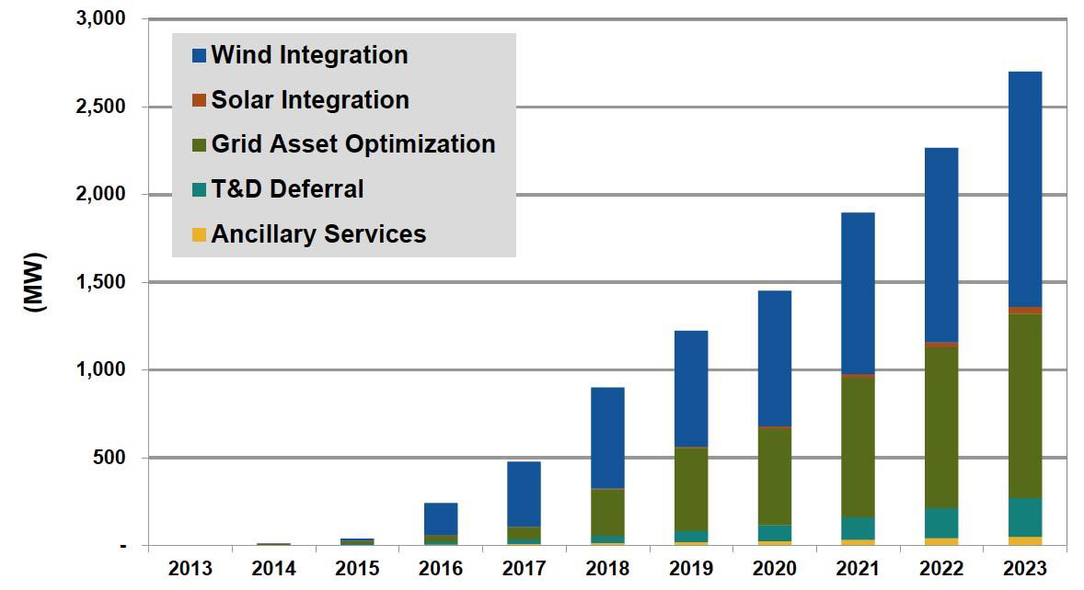
Navigant Research’s forecast of global CAES applications by year (2013)

Flywheels Market and Technology
The flywheel market is in its infancy. A leader in this sector appears to be Beacon Power. DOE assisted with demonstration dollars for this technology as well.

These are spinning batteries housed in a vacuum in “a near frictionless environment.” They can charge and discharge up to 175,000 times and are modular, where facilities can be from 100 kilowatts to tens of megawatts in size. They can be deployed for grid balancing purposes and in microgrid contexts. They can discharge anywhere from seconds up to 15 minutes, with a reaction time of milliseconds.

Beacon Power Flywheel
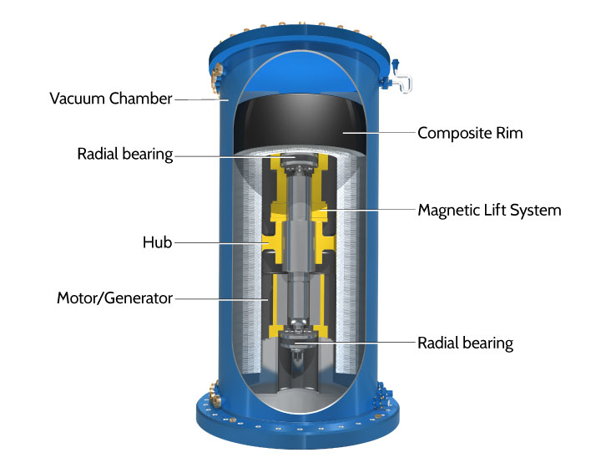
Source: Beacon Power
Beacon has three facilities operating located in New York, Massachusetts and Pennsylvania. In terms of cost, the 20-megawatt in Stephentown, New York came in at $69 million. Beacon expects its next installation to be half the cost of current facilities.

Ultracapacitor Market and Technology
Ultracapacitors are storage technologies that can be charged in seconds and can discharge for seconds to a few minutes. They can be used to firm variable output from wind and solar PV. Their strength is that they can be charged and discharged millions of times. The market is in its infancy for grid applications.

Maxwell Technologies is testing a 28 kilowatt/15 minutes ultracapacitor at the University of San Diego’s microgrid.

Navigant expects the advanced battery (ultracapacitors, and lithium sulfur, solid electrolyte, magnesium-ion and flow batteries) market to reach $9.4 billion. In 2014 the market was worth $182 million.

Hollow Ball Storage Technology (Kugelpumpspeicher)
Last year German researchers announced a storage technology that it’s a hollow ball containing a turbine that would be submersed underwater (700 meters is the goal now). Water would be let in to run the turbine and pumped out at night when excess power were on the grid. The estimate is that the system would be 80-85% efficient, according to modeling. The estimate is that they would cost 1200-1400 euors/kilowatt and run at pennies per kilowatt-hour. They would be designed to run for 4 to 8 hours. Pilots are to be completed by the end of 2015.

Hollow Ball Energy Storage
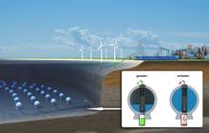
Source: Federal Republic of Germany

Wave Market and Technology
US offshore wave potential is estimated to be about one quarter of the country’s total electric demand. The largest resources are on the East and West Coasts. The average capacity is about 9 megawatts per mile. Technologies are still in the pilot/demonstration stage but the demonstration facilities are becoming larger in preparation for commercialization. The industry is now populated by small companies. They receive government support for piloting their prototypes. However, Lockheed Martin is involved in a pilot off the coast of Australia. Analysts believe that large companies like Siemens and GE will have to get involved before this market segment takes off. The industry points to having nothing in the water 10 years ago to multiple-megawatt pilots in the water today. Its representatives expect “substantial amounts of grid-connected wave power” within 20 years.

The regions of activity are Australia, the UK (particularly Scotland), and, in the US, it’s expected that the Pacific Northwest and Alaska will be the likely initial areas of development. A pilot was approved off the coast Oregon in the spring of 2014. The UK resource is large compared to overall demand. The country estimates that wave (and tide) technology could provide up to 75% of the country’s electric needs.

Technologies
Pelamis Wave Power Machine
Pelamis Wave Power, a Scottish company, is an example of the potential difficulty the industry may have to maintain funding in order to fully develop a technology. Its machine is designed to operate in 50 meters of water (164 ft.) 2 to 6 miles from the coast. It is rated at 750 kilowatts with a capacity factor of 20 to 40%, enough to power 500 homes per year.

The system is a series of linked tubes that face into waves. As the waves pass, hydraulic pressure is converted to electricity and transmitted to land via cables.

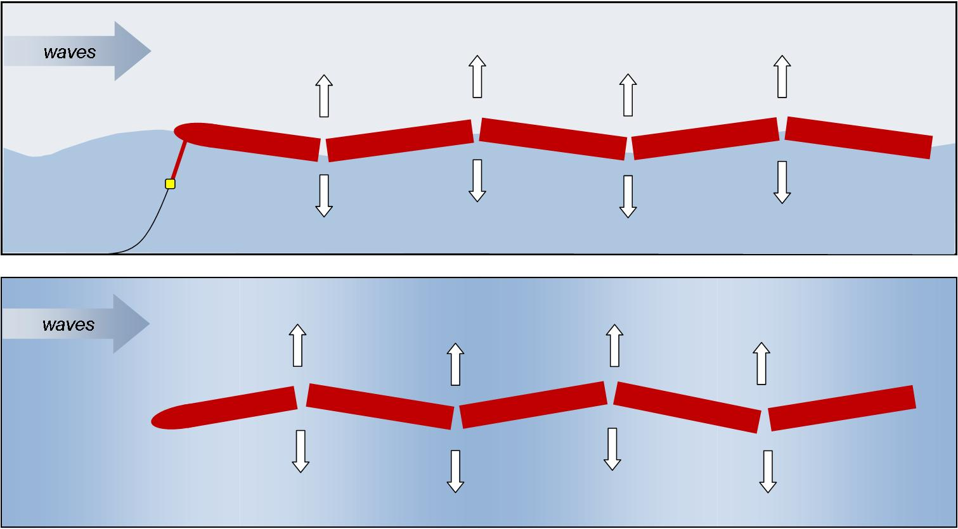
Source: Pelamis Power

In February of 2013, the company received $2.1 million for a pilot off the UK coast. However, in November of 2014 the company announced that it has lost its funding and is assessing its future.

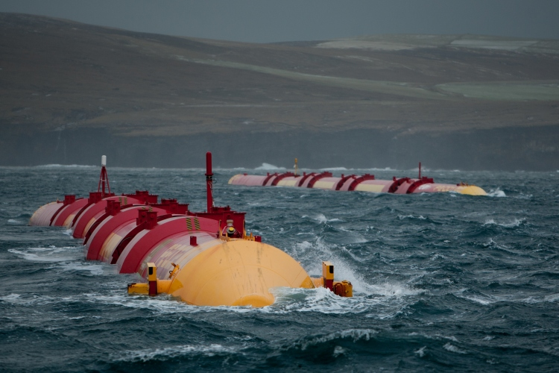
Source: Pelamis Power

Carnegie Wave Power Machine
Carnegie Wave, an Australian-based company, has had more successful with its design. The company’s CETO unit is designed to deliver electricity and desalinated fresh water. It is fully submerged and pumps pressurized salt water to shore where hydro-electric turbines generate electricity.

Carnegie successfully demonstrated its 80 kilowatt model off the coast of Perth, Australia, in 2011. Since then, it has received permission and funding to test its 240 kilowatt CETO 5 unit, set to be the first demonstration worldwide linking 3 machines. It is set to begin operation this year. Carnegie is working toward its 1 megawatt CETO 6 design demonstration slated for 2016.

CETO 5 Unit
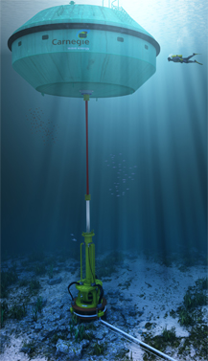
Source: Carnegie Wave

M3 Wave Power Technology
M3 Wave Power LLC has developed a “submerged pressure differential wave energy device.” It deployed a unit for testing in September 2014 off the coast of Astoria, Oregon. The technology is designed for island villages where high-cost diesel units are used to generate electricity. Its current goal is to development a 150 kilowatt unit for such purposes. The pilot is 30 feet long and 8 feet wide. While it is generating power, it is not connected to the grid. The unit “turns the pressure waves under ocean waves into alternating expansion and contraction cycles of an air-filled system which, in turn, drives an air turbine connected to an electrical generator.”

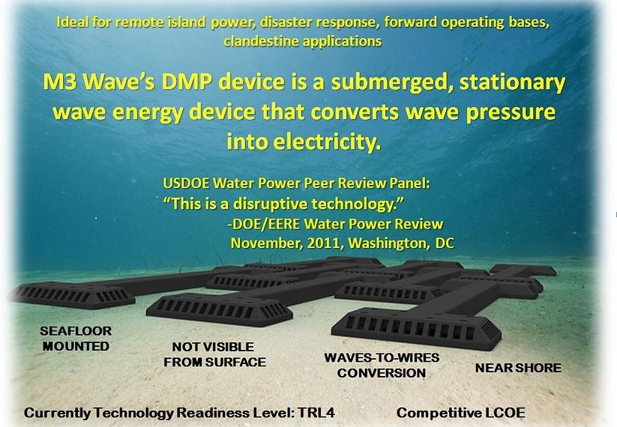
Source: M3 Wave Power LLC

Fuel Cell Market and Technologies
Market and Developments
The global fuel cell market in terms of installed capacity is expected to grow over 22% annually from 2014 to 2020, from 160 megawatts today to over 664 megawatts in 2020. In 2013 50,000 units were shipped, expected to increase to almost 800,000 in 2020 – a 50% increase per year.

Fuel cells combine hydrogen and oxygen in a chemical reaction to produce electricity. Natural gas and methanol are examples of sources of hydrogen. Although there may be minor emissions depending on the source of hydrogen, the primary waste product from the reaction is water. Water is another potential source of hydrogen.

DOE and private research dollars have made significant strides in creating a viable market for fuel cells. These efforts have reduced costs by more than 50% since 2006 and 30% since 2008. Fuel cell “durability had doubled.” Moreover, the amount of platinum (the principle and very expensive catalyst in fuel cells) has declined 80% since 2005.

In 2013 North America dominated the market with over 42% of installed capacity. It is expected to maintain the lead through 2020 with commericialization of fuel-cell powered vehicles. Asia followed with about 37% of installed capacity. Europe is expected to have the fastest growth in installed capacity (33% per year) over the next six years. The leading countries are Germany, Sweden, Denmark, and Norway, which have already begun to invest in fuel cell infrastructure. Lack of infrastructure and relative high cost is expected to hamper fuel cell deployment in developing countries.

This sector is highly concentrated at the moment. Five companies comprise 80% of the market – Fuel Cell Energy had 30% market share in 2013. Other dominant players are Ballard, Toshiba, Panasonic, and Clearedge.

The top five leading states are New York, Connecticut, Ohio, California, and South Carolina. California, Connecticut, and New York finance fuel cells through PACE (Property Assessed Clean Energy) programs.

California Zero Emission Vehicle Goals
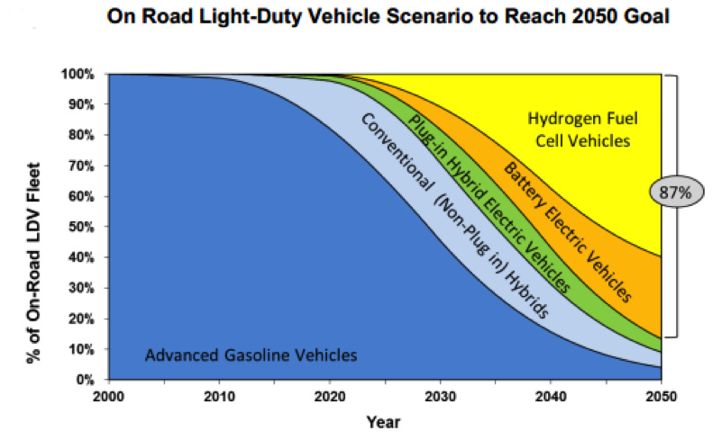
Source: California Energy Commission

In terms of what’s known as the “micro-CHP market,” fuel cells have overtaken combustion turbines (i.e. diesel generators) in the global residential market. This is being driven mainly by Japan, with Germany following. Residential fuel cells represent 64% of all sales.

Technologies
There are three applications for fuel cells: portable, stationary, and transportation. In terms of the electric grid and transportation, a portable fuel application would be in the context of “auxiliary power units,” not used for propulsion but, for instance, for purposes of refrigeration in trucks and RVs. Stationary applications would be for residences, combined-heat and power in commercial and industrial contexts, backup power supply (UPS or uninterrupted power supply) when the grid fails, such as at data centers or hospitals.

Proton exchange membrane fuel cells (PEMFC) account most installed capacity globally (40%) and most shipments (88%) due to their wide range of applications – vehicles, telecommunications, and primary and backup systems. Molten carbonate fuel cells (MCFC) take second place in terms of installed capacity and are expected to experience the largest annual growth over the next 6 years – 56%. They are larger systems used in combined heath and power contexts, such as at industrial facilities.

The DOE is funding research with UPS to fit 15 vans with fuel cell/hybrid technology and to develop a delivery van with 150-mile radius. It has a similar effort with FedEx. DOE is also assisting Sprint with installing fuel cell backup systems “for rooftop telecommunications equipment.”

Moreover, DOE is funding research to gather data on fuel cell-powered cars with Toyota, Honda, GM, Hyundai, Nissan and Daimler Benz. Hyundai has begun delivery of a fuel cell-powered hybrid in Southern California.

Microgrid Markets and Technology
DOE defines microgrids “a local energy grid with control capability, which means it can disconnect from the traditional grid and operate autonomously.”

Currently, the market seems concentrated at remote locations (for instance, islands that rely on high-cost diesel) and facilities that require highly reliable power – military bases, research facilities, data centers. But GTM Research believes the market is ready to expand to communities, small cities, and public institutions, reaching 1.8 gigawatts by 2018.

The main power source of most microgrids now are combustion technologies (natural gas-fired turbines, for instance). However, analysts assert things will change over the next 5 years with declines in the cost of energy storage, solar PV (80% over the last five year) and wind turbines (35% since 2008).

These developments are being driven by state CHP incentives and resiliency programs, along with microgrid investments by the Department of Defense.

Top Microgrid States by Capacity (MW) and Installation Numbers
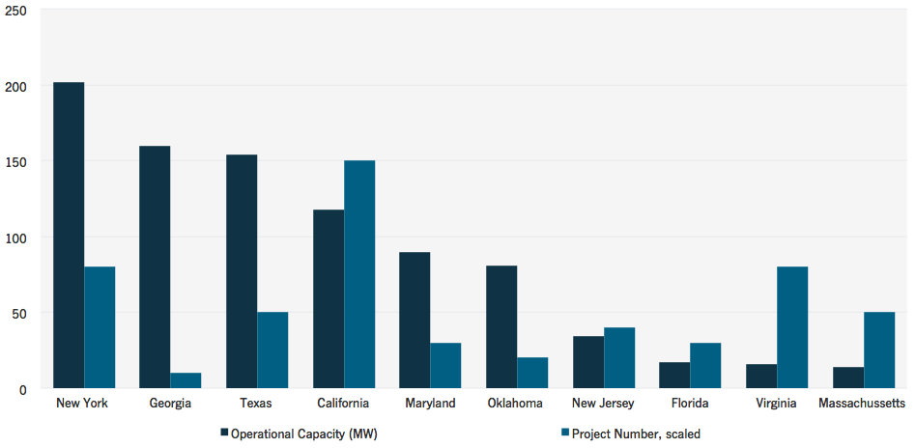
Source: GTM Research (2014)

The US microgrid market is expected to be valued at $3 billion by 2018. The global market for microgrid “enabling technologies” is expected to be $155 billion by 2023.
These include fuel cells, solar and distributed wind, advanced inverters, control systems, plug-in electric vehicle advanced storage systems, combined heat and power systems (which would include natural gas turbines) and others.

Microgrid installations in the US span military bases, communities, island communities, and public institutions. GTM Research plotted these installations for 2014:

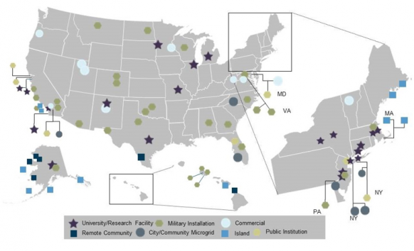
Source: GTM Research

Utility investment in microgrids is expected to climb to almost $6 billion by 2023. Currently, most of these investments are in the public power sector (municipal utilities), who own the local distribution system. This could present a problem for communities served by investor-owned utilities, who own the distribution system.
Navigant concludes that most of the estimated $8.4 billion (annually by 2020) remote microgrid market will take place in developing countries. However, there will be increasing investment in North America and Europe.

Development, Testing, Piloting Demonstration: The Advantage of Renewables and Distributed Technologies Over New Conventional Power Plant Designs
The modular nature of solar, wind, storage, fuel cells, etc. gives them a distinct advantage over new nuclear and coal-fired power designs. They can be developed, tested, piloted, and demonstrated over multiple generations prior to commercialization, which makes them (other than their modular nature and the ability to be mass produced) much less of a financial risk than new nuclear or coal-fired construction which inevitably culminate in delays and cost overruns. Prices can be set. Operating capabilities are known.

This is how microgrid technologies are being developed and commercialized. In fact, they are being tested in actual or near actual operating conditions.

NREL’s 182,000 square foot Energy System Integration Facility is an example. There NREL is testing such technology “at full power and actual load levels in real-time simulations to evaluate component and system performance before going to market.” Currently, NREL is testing microgrid control systems developed by GE and EPRI (Electric Power Research Institute). The idea is to standardize the capabilities of control systems so that they can be deployed in any microgrid context and scalable. Control systems (telecommunications technology essentially) balance supply and demand of power on the microgrid to maintain system reliability. ESIF hosted 40 private partners in its first year of operation.

Another live lab for testing distributed energy technology is University of San Diego’s microgrid. Covering over 92% of its sprawling campus, U of San Diego is testing ultracapacitors, flow-battery technology, concentrating solar technology, and the first commercial size molten-carbonate fuel cells, electric-vehicle charging timed around the microgrid’s electric demand, the testing of batteries for grid application that have surpassed their useful life in electric cars.

Building Efficiency Market and Technologies
Building efficiency is critically important to the sustainable grid design. In the US, buildings consume 41% of all energy use, 73% of electricity consumption, and are responsible for 38% of all carbon dioxide emissions. Also importantly, building efficiency is big business.

The US Green Building Council has worked with the private sector develop standards for efficient building construction referred to as Leadership in Energy and Environment Design (LEED). It projects that soon up to 48% of non-residential construction will be LEED, equating to $120 to $140 billion investment. Only 2% of commercial construction in 2005, LEED grew to 28 to 35% of commercial construction by 2010. In 2012, the potential market was considered to be a up to $150 billion, which would create one million jobs.

In 2014, Navigant conducted a study of the world building retrofit market, reviewing the potential for energy efficiency in commercial and public buildings. Navigant assessed heating and air conditioning, water conservation, lighting, building envelope measures, customer energy generation, and installation. It found that by 2024 building owners will have invested over $900 billion in such efficiency retrofits.

A small but growing sector is the net zero energy building market. Estimated at about $629 million worldwide in 2014, it is expected to expand to $1.4 trillion by 2035. There are 400 such buildings documented globally, with 25% in the US and Canada.

Walgreens opened its first net zero energy building in Illinois in November of 2013, featuring 850 solar panels , 2 wind turbines, and a geothermal heat pump. Habitat for Humanity finished its first net zero energy home in Minneapolis. Although most of these buildings are small, the Bullitt Foundation constructed a 52,000-square foot office building in Seattle and NREL a 220,000 square foot net zero energy office building in Colorado. The Obama Administration has ordered all new federal buildings to be net zero energy by 2030. California has mandated that all residential construction be net zero energy beginning by 2020 and 50% of the floor space of existing state buildings net energy zero by 2025.

Rocky Mountain Institute is working with the University of California, Fort Collins, Colorado, and Arizona State on net zero energy communities. At the University of California, RMI and the University are creating a net zero energy district called the West Village, where 3,000 students and 500 faculty will reside. A portion is complete and achieved 87% of their demand the first year. Arizona State wants to be net zero carbon emissions by 2025 – a much more stringent standard than net zero energy. RMI and officials of Fort Collins, Colorado are developing a net zero energy project for the downtown district of the city and the Colorado State University campus.

“Renewable Energy Investment Surges, Nearly Surpassing 2011 High-Water Mark.” Think Progress, January 9, 2015. http://thinkprogress.org/climate/2015/01/09/3609869/renewable-energy-investment-surges/. And “GLOBAL TRENDS IN CLEAN ENERGY INVESTMENT” Rebound in clean energy investment in 2014 beats expectations” Bloomberg New Energy Finance, January 9, 2015. http://about.bnef.com/presentations/clean-energy-investment-q4-2014-fact-pack/content/uploads/sites/4/2015/01/Q4-investment-fact-pack.pdf
“Solar Power in the U.S. Doubled in 2014 and Other Good Clean Energy News.” Truthdig.com, December 6, 2014. http://www.truthdig.com/report/item/solar_power_in_us_doubled_2014_other_good_clean_energy_news_20141206/
“Renewables Comprise Majority Of New Generation For November, Year.” North American Wind Power, December 24, 2014 http://www.nawindpower.com/e107_plugins/content/content.php?content.13786
“Power Sector Employment Declines, Except for Renewable Electricity Generators.” Energy Information Administration, December 19, 2014. http://www.eia.gov/todayinenergy/detail.cfm?id=19271
“Solar Energy's Future Is Shining, But Is First Solar Still Competitive? The Algorithmic Perspective.” Seekingalpha.com, November 29, 2014. http://seekingalpha.com/article/2718155-solar-energys-future-is-shining-but-is-first-solar-still-competitive-the-algorithmic-perspective
See Diane Cardwell, “Solar and Wind Energy Start to Win on Price vs. Conventional Fuels.” New York Times, November 23, 2014. http://www.nytimes.com/2014/11/24/business/energy-environment/solar-and-wind-energy-start-to-win-on-price-vs-conventional-fuels.html?_r=1 and Chip Register, “Solar Continues Trumping Fossil Fuel Pricing, With More Innovations To Come.” Forbes, September 11, 2014. http://www.forbes.com/sites/chipregister1/2014/09/11/solar-continues-trumping-fossil-fuel-pricing-with-more-innovations-to-come/
Ryan Holeywell, “Report: Energy Efficiency Could Cost US Utilities $48 Billion.” Fuelfix.com, December 8, 2014. http://fuelfix.com/blog/2014/12/08/report-energy-efficiency-could-cost-u-s-utilities-48-billion/
“A Solar System Is Installed in America Every 2.5 Minutes.” Greentechsolar, January 12, 2015. http://www.greentechmedia.com/articles/read/a-solar-system-is-installed-in-america-every-2.5-minutes
“US Solar Market Insight: Q3 2014.” SEIA and GTM Research, 2014. http://www.seia.org/sites/default/files/resources/iV39f8059N.pdf
“Solar Industry: Is Grid Parity Around the Corner?” UBS, June 10, 2014. (subscription required)
“Solar Power & Energy Storage: Policy Factors vs. Improving Economics.” Morgan Stanley, July 28, 2014. http://forms.greentechmedia.com/Extranet/95679/Morgan%20Stanley%20Solar%20Power%20&%20Energy%20Storage%20Blue%20Paper%20July%2029%202014.pdf
“Deutsche Bank anticipates 2015 global solar PV demand at 54 GW.” SolarServer, January 1, 2015. http://www.solarserver.com/solar-magazine/solar-news/current/2015/kw03/deutsche-bank-anticipates-2015-global-solar-pv-demand-at-54-gw.html
Giles Parkinson, “UBS and Citigroup Expect Massive Solar-EV Revolution.” Energy Post, August 25, 2014. http://www.energypost.eu/ubs-citigroup-warn-investors-massive-revolution-energy-industry/
“Solar Technique Achieves Record-High 40% Efficiency.” ThinkProgress, December 8, 2014. http://thinkprogress.org/climate/2014/12/08/3600599/record-high-solar-conversion-efficiency/
“Hybrid Material May Help Crush Solar Cell Efficiency Record.” IFL Science, October 9, 2014. http://www.iflscience.com/technology/hybrid-material-may-help-crush-solar-cell-efficiency-record
“New Materials Yield Record Efficiency for Polymer Solar Cells.” Science Daily, November 10, 2104. http://www.sciencedaily.com/releases/2014/11/141110110424.htm
“New Technique Offers Spray-On Solar Cells.” University of Toronto Engineering News, December 5, 2014. http://news.engineering.utoronto.ca/new-technique-offers-spray-on-solar-power/
“The Netherlands is Set to Open First Solar Bike Land.” Think Progress, November 11, 2014. http://thinkprogress.org/climate/2014/11/11/3591195/netherlands-solar-road/
“Solar Panels that You Can Drive, Ride, or Walk On.” Indiegogo. https://www.indiegogo.com/projects/solar-roadway
“Size Matters: New See Through Solar Windows Go Big.” Cleantechnica, March 27, 2014. http://cleantechnica.com/2014/03/27/see-through-solar-windows-go-big/
“Solar Power in the U.S. Doubled in 2014 and Other Good Clean Energy News.” Truthdig, December 6, 2014. http://www.truthdig.com/report/item/solar_power_in_us_doubled_2014_other_good_clean_energy_news_20141206/
“American Wind Energy Association: U.S. Wind Industry Third Quarter 2014 Market Report.” AWEA, October 20, 2014. http://awea.files.cms-plus.com/FileDownloads/pdfs/3Q2014%20AWEA%20Market%20Report%20Public%20Version.pdf
Bureau of Ocean Energy Management web site. http://www.boem.gov/renewable-energy-program/renewable-energy-guide/offshore-wind-energy.aspx
Truthdig, December 2014.
“Global Wind Capacity to Double in 5 Years.” Cleantechnica, April, 15 2014. http://cleantechnica.com/2014/04/15/global-wind-power-capacity-projected-nearly-double-5-years-charts/
“Wind Turbine Rotor Blade Market to be Worth $16,982 Million by 2019.” PR Newswire, December 11, 2014. http://www.prnewswire.com/news-releases/wind-turbine-rotor-blade-market-worth-16982-million-by-2019-285470111.html
“Advancements in Wind Turbine Technology: Improving Efficiency and Reducing Cost.” Power Engineering, March 14, 2014. http://www.power-eng.com/articles/print/volume-118/issue-3/features/advancements-in-wind-turbine-technology-improving-efficiency-and-reducing-cost.html
“What’s New in Wind Turbine Technology.” Renewable Energy World, July 10, 2014. http://www.renewableenergyworld.com/rea/news/article/2014/07/whats-new-in-wind-technology
“MHI Vestas Says Wind Turbine Sets Generation Record”. Bloomberg, October 17, 2014. http://www.bloomberg.com/news/2014-10-17/mhi-vestas-says-wind-turbine-sets-generation-record.html
Boco Rock Wind Farm web site http://bocorockwindfarm.com.au/milestones
“Torque Wind Turbine is the World’s Most Advanced Small Wind Turbine.” Eco-Business.com, December 11, 2014 http://www.eco-business.com/press-releases/torque-wind-turbine-is-the-worlds-most-advanced-small-wind-turbine/
Pumped storage is mature and in use, therefore the paper will address pumped storage only in passing.
Demand response is a way to reduce electric demand when needed to balance demand and supply. As an Example, commercial buildings with building controls can modulate lighting, air conditioning, ventalization and when combined with other large office buildings can reduce electric usage during peak demand. Companies that generate their own power can bid it into the market. This market is now at 29 gigawatts and represents 6% of national peak demand at the moment. A success law suit by utilities against a FERC rule that implemented this program has been appealed by the Obama Administration. Utilities are fighting against the market, a more efficient grid, customer choice, renewables, across the board.
See “PJM Renewable Integration Study.” PJM, March 31, 2014. http://variablegen.org/wp-content/uploads/2014/07/pris-executive-summary.pdf and
DOE Energy Storage Database http://www.energystorageexchange.org/projects
“Innovations in Storage Boost Renewable Energy.” October 31, 2014. http://www.csmonitor.com/World/Making-a-difference/Change-Agent/2014/1031/Innovations-in-storage-boost-renewable-energy
“Energy Storage for the Grid and Ancillary Services.” Navigant, 3Q 2014. http://www.navigantresearch.com/research/energy-storage-for-the-grid-and-ancillary-services
“Is Battery Storage the Next Solar?” Utility Dive, October 10, 2014. http://www.utilitydive.com/news/is-battery-storage-the-next-solar/316875/
“Commercial, Residential and Community Energy Storage.” Navigant, 4Q 2014. http://www.navigantresearch.com/research/community-residential-and-commercial-energy-storage
“Utility-Scale Battery Storage Costs Dropping.” CleanTechnica, December 18, 2014. http://cleantechnica.com/2013/12/18/utility-scale-battery-storage-costs-dropping/
“Utility Dive, December 2014.
“Where Energy Storage Will Expand and Why.” Utility Dive, January 7, 2015. http://www.utilitydive.com/news/where-the-energy-storage-expansion-will-happen-first-and-why/346265/
“The Top 10 Energy Storage Stories of 2014.” GreenTechMedia, December 23, 2014. http://www.greentechmedia.com/articles/read/the-top-10-energy-storage-stories-of-2014
GreenTechMedia, December 2014.
“Salt Water Powered Car Gets European Approval – Yes, It’s Real.” Themindunleashed.org, September, 6, 2014. http://themindunleashed.org/2014/09/move-tesla-new-car-powered-salt-water-900-horsepower.html
Themindunleashed.org, September 2014.
Sodium-Ion Battery. Wikipedia. http://en.wikipedia.org/wiki/Sodium-ion_battery
“Liquid-Metal Batteries Get Boost From Molten Lead.” Nature, September 21, 2014. http://www.nature.com/news/liquid-metal-batteries-get-boost-from-molten-lead-1.15967
“EOS: Battery Storage Will be Cost-Competitive in 18 Months.” Utility Dive, December 19, 2013. http://www.utilitydive.com/news/eos-battery-storage-will-be-cost-competitive-in-18-months/207750/
EOS. http://www.eosenergystorage.com/technology-and-products/
See “SustainX Delivers Compressed Air Storage System.” Nanalyze, July 1, 2014. http://www.nanalyze.com/2014/07/sustainx-delivers-compressed-air-energy-storage-system/ and “SustainX Technology Report: SustainX Smart Grid Program.” SustainX, July 30, 2014. https://www.smartgrid.gov/sites/default/files/doc/files/20140717%20-%20SustainX%20DOE%20Smart%20Grid%20TRP%20Interim.pdf
Beacon Power Website. http://beaconpower.com/carbon-fiber-flywheels/
“Flywheel of Fortune.” Slate, August 2014, http://www.slate.com/articles/business/the_juice/2014/08/beacon_power_the_department_of_energy_loan_recipient_is_making_a_comeback.html
Slate, August 2014.
“Beacon Sees Demand Doubling for Energy-Storage Flywheels.” Bloomberg, August 5, 2014. http://www.bloomberg.com/news/2014-08-05/beacon-sees-demand-doubling-for-energy-storage-flywheels.html
UC San Diego is Building the ‘Motel 6’ of Microgrids. GreenTechMedia, May 19, 2014. http://www.greentechmedia.com/articles/read/byrom-washom-master-of-the-microgrid
“Next-Generation Advanced Batteries Will Reach $9.4 Billion in Annual Revenue by 2023.” Navigant, June 18, 2014. http://www.navigantresearch.com/newsroom/next-generation-advanced-batteries-will-reach-9-4-billion-in-annual-revenue-by-2023
“Kugelpumpspeicher Unterwasser.” Energy Storage Website of the Federal Republic of Germany. http://forschung-energiespeicher.info/projektschau/gesamtliste/projekt-einzelansicht/95/Kugelpumpspeicher_unter_Wasser/
Mapping and Assessing of the United States Ocean Wave Energy Resource 2011 http://www1.eere.energy.gov/water//pdfs/mappingandassessment.pdf
“Why Wave Power Energy has Lagged Behind.” GreenBiz, May 14, 2014. http://www.greenbiz.com/blog/2014/05/14/why-wave-power-energy-has-lagged-far-behind
GreenBiz, May 2014.
Pelamis Waver Power Web Site: http://www.pelamiswave.com/pelamis-technology
“Pelamis Selected for 1.4 Million Pound ETI Wave Power Project.” Pelamis, February 27, 2013. http://www.pelamiswave.com/news/news/127/Pelamis-selected-for-1.4m-ETI-wave-power-project
“Pelamis Wave Power Limited (“Pelamis”) to be Put into Administration.” Pelamis, November, 21, 2014. http://www.pelamiswave.com/news/news/173/Pelamis-Wave-Power-Limited-Pelamis-to-be-put-into-administration
CETO in Wikipedia http://en.wikipedia.org/wiki/CETO
“CETO Overview.” Carnegie Wave Web Site http://carnegiewave.com/ceto-technology/ceto-overview.html
“M3 Wave Announces Successful Deployment of Submerged Wave Energy Device Off Oregon Coast.” Oregon Wave Energy Trust, September 12, 2014. http://oregonwave.org/news/m3-wave-announces-successful-deployment-submerged-wave-energy-device-oregon-coast/
Global Fuel Cell Market is Expecting Growth at CAGR of 49.1% from 2014 to 2020: New Report by Grand View Research, Inc. Nasdaq Globenewswire, November 13, 2013. http://globenewswire.com/news-release/2014/11/13/682920/10108080/en/Global-Fuel-Cell-Market-Is-Expecting-Growth-At-CAGR-Of-49-1-From-2014-To-2020-New-Report-By-Grand-View-Research-Inc.html
“Energy Department Invests Over $7 Million to Commercialize Cost-Effective Hydrogen and Fuel Cell Technologies.” DOE, December 17, 2013. http://energy.gov/articles/energy-department-invests-over-7-million-commercialize-cost-effective-hydrogen-and-fuel?__utma=1.492133890.1394232753.1394232753.1394232753.1&__utmb=1.1.10.1394232753&__utmc=1&__utmx=-&__utmz=1.1394232753.1.1.utmcsr=google|utmccn=%28organic%29|utmcmd=organic|utmctr=%28not%20provided%29&__utmv=-&__utmk=190458283
“Fuel Cell Market by Product and Segment Forecasts to 2020.” Grand View Research, April 2014. http://www.grandviewresearch.com/industry-analysis/fuel-cell-market
Grand View Research, April 2014.
“State of the States: Fuel Cells in American.” DOE Fuel Cell Technologies Office, December 2014. http://energy.gov/sites/prod/files/2014/12/f19/fcto_state_of_states_2014_1.pdf
“Fuel Cells Overtake Engines in Micro CHP Scene.” Cogeneration, July 15, 2013. http://www.cospp.com/articles/2013/07/fuel-cells-overtake-engines-in-micro-chp-scene.html
Navigant expects the global stationary fuel cell market to increase from $1.4 billion in 2014 to $40 billion in 2022. (“Stationary Fuel Cells.” Navigant, 1Q 2014. http://www.navigantresearch.com/research/stationary-fuel-cells)
Grand View Research, April 2014.
Grand View Research, April 2014.
DOE, December 2013.
“First Commercially Available Fuel Cell Electric Vehicles Hits the Streets.” DOE, December 10, 2014. http://energy.gov/eere/articles/first-commercially-available-fuel-cell-electric-vehicles-hit-street
“Hydrogen Fuel Finally Graduating from Lab to City Streets.” Bloomberg, June 5, 2014. http://www.bloomberg.com/news/2014-06-04/clean-hydrogen-advances-amid-fuel-cell-technology-gains.html
DOE in “Here’s Why the Forecast for Microgrids Looks this Sunny.” GreenBiz, July 7, 2014. http://www.greenbiz.com/blog/2014/07/07/power-microgrids-unfolding-now
GreenBiz, July 2014.
See GreenBiz, July 2014 and “US Microgrid Capacity Will Exceed 1.8 GW by 2018.” GreenTechMedia, June 26, 2014. http://www.greentechmedia.com/articles/read/US-Microgrid-Capacity-Will-Exceed-1.8-GW-by-2018
GreenTechMedia, June 2014.
GreenBiz, July 2014.
“North Microgrids 2014: The Evolution of Localized Energy Optimization.” GTM Research, June 26, 2014. http://www.greentechmedia.com/research/report/north-american-microgrids-2014
GTM Research, June 2014.
“Investment in Microgrid Enabling Technologies is Expected to Exceed $155 Billion Through 2023. Navigant, December 22, 2014. http://www.navigantresearch.com/newsroom/investment-in-microgrid-enabling-technologies-is-expected-to-exceed-155-billion-through-2023
“Study: Utility Microgrid Annual Revenue to Reach $6 Billion by 2023.” UtilityDive, December 23, 2014. http://www.utilitydive.com/news/study-utility-microgrid-annual-revenue-to-reach-6b-by-2023/346896/
“Remote Microgrids Will Surpass $8.4 Billion in Annual Revenue by 2020.” Navigant, September 25, 2013. http://www.navigantresearch.com/newsroom/remote-microgrids-will-surpass-8-4-billion-in-annual-revenue-by-2020
“NREL to Advance Technologies for Microgrid Projects.” NREL, December 10, 2014. http://www.nrel.gov/news/press/2014/15431.html
The U of San Diego’s microgrid is powered by two natural gas turbines, 3 megawatts of solar, battery storage, fuel cells, and building efficiency and controls.
MCFCs are high-temperature fuel cells that use an electrolyte composed of a molten carbonate salt mixture http://en.wikipedia.org/wiki/Molten_carbonate_fuel_cell
See “A Tour of America’s Fanciest Microgrid.” E&E News, March 13, 2014. http://www.eenews.net/stories/1059996047 and “UC San Diego Is Building the ‘Motel 6’ of Microgrids.” GreenTechMedia, May 19, 2014. http://www.greentechmedia.com/articles/read/byrom-washom-master-of-the-microgrid
“Green Building Facts.” US Green Building Fact Sheet http://www.usgbc.org/Docs/Archive/General/Docs18693.pdf
US Green Building Fact Sheet
“Energy Efficiency Retrofits for Commercial and Public Buildings.” Navigant, 1Q 2014. http://www.navigantresearch.com/research/energy-efficiency-retrofits-for-commercial-and-public-buildings
“Net Zero Energy Buildings.” Navigant, 3Q 2014. http://www.navigantresearch.com/research/zero-energy-buildings
“It Takes a Village: Moving Beyond Net-Zero Buildings to Net-Zero Districts and Communities.” RMI, Winter 2014. http://www.rmi.org/winter_2014_esj_it_takes_a_village
RMI, 2014.

